Northwind Catalog Project Report
By: Mayank Sharma

1. Project Initialization & Database First Approach
I started by creating a blank solution named NorthwindCatalog.
Inside this solution, I added three projects:
- NorthwindCatalog.Services – handles business logic and data access
- NorthwindCatalog.Web – frontend MVC application
- NorthwindCatalog.Tests – unit testing layer
- 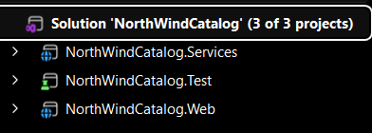
After setting up the structure, I installed required NuGet packages in the Services project:
- Microsoft.EntityFrameworkCore.SqlServer
- Microsoft.EntityFrameworkCore.Tools
- AutoMapper.Extensions.Microsoft.DependencyInjection
Then I used the Database First approach to scaffold models:
dotnet ef dbcontext scaffold "YourConnectionString" Microsoft.EntityFrameworkCore.SqlServer -o Models
This generated all entity classes and the DbContext automatically from the database.

2. Fluent API Configuration
Inside the DbContext file, I overrode the OnModelCreating method to define relationships and constraints.
Example work done:
- Configured one-to-many relationship between Category and Product
- Set precision for fields like price
- Applied table configurations
- 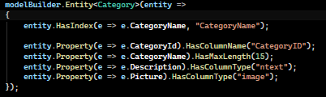
- 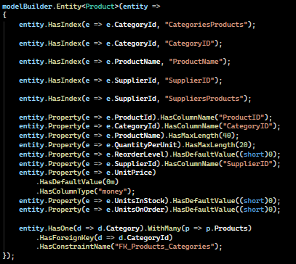
This ensures better control over database mapping instead of relying only on conventions.

3. Data Transfer Objects (DTOs)
I created a DTOs folder inside the Services project and defined:
- CategoryDto
- ProductDto
- CategorySummaryDto
Special logic:
- In ProductDto, I added a calculated property:
InventoryValue = UnitPrice * UnitsInStock
This ensures the calculation is handled at the API level instead of UI.

4. AutoMapper Configuration
I created a mapping class using AutoMapper:
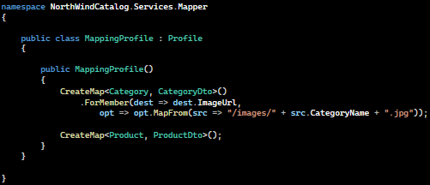This removed manual mapping and kept the code clean.

5. Repository Pattern Implementation
I followed the Repository Pattern to separate data access logic.
Created interfaces:
- ICategoryRepository
- IProductRepository
Then implemented them with database logic.
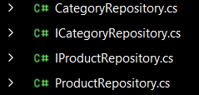
Important optimization:
- Used LINQ projection in GetCategorySummariesAsync() to fetch only required data instead of full entities.
This improves performance and reduces memory usage.

6. Web API Layer
I created API controllers and injected:
- Repository interfaces
- AutoMapper
Endpoints created:
- GET /api/categories
- GET /api/products/by-category/{id}
- GET /api/products/summary
- 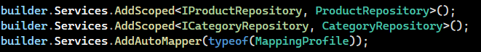
These APIs were tested using Swagger and returned proper JSON responses.

7. MVC Consumption
In the MVC project, I registered HttpClientFactory in Program.cs.
Then created controllers:
- CategoriesController
- ProductsController
- 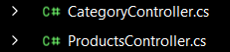
These controllers call APIs using HttpClient like:
var categories = await _client.GetFromJsonAsync<List<CategoryDto>>("api/categories");
This connects frontend with backend APIs.

8. UI Implementation
For frontend design, I used Bootstrap.
Implemented:

Category Page
- Displayed categories in card format
- Each card shows name and image
- Click redirects to products page
- 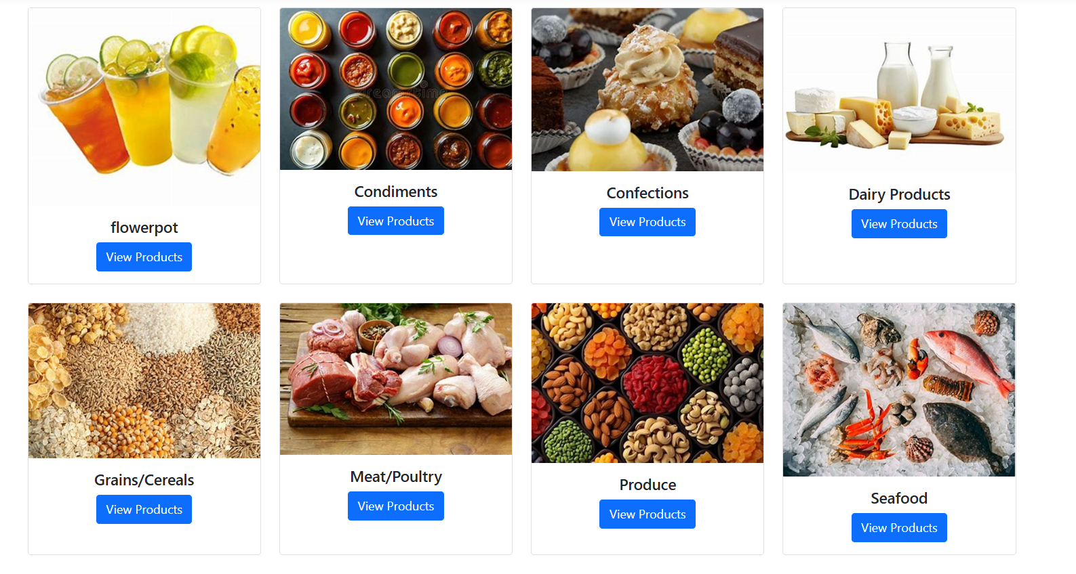

Product Page
- Products displayed using cards
- Shows:
  - Product Name
  - Price
  - Stock
  - Inventory Value
  - 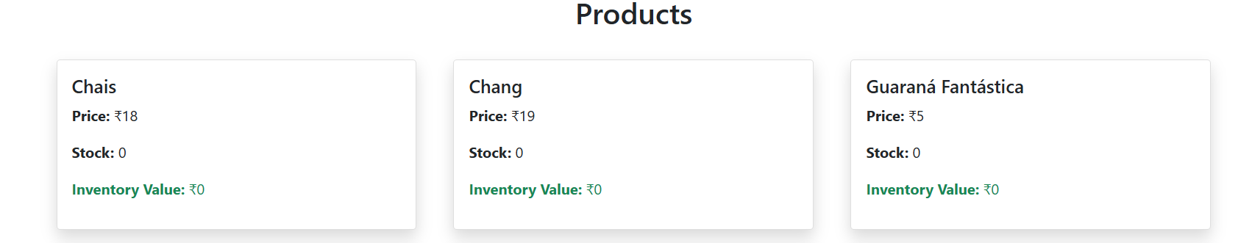

Summary Page
- Displayed in table format
- Shows aggregated category data

The UI is fully responsive and clean.

